HELP US HELP YOU
WHEN TO USE THE COOP VS. HELPDESK?
- Coop will be still be available and used to house training material, documents, processes, policies and procedures
- New condo projects –or- condo project that do not have a loan or property associated with them – USE CONDO DESK ON COOP
- Do not reply to the ticket to thank the agent, this will create a pending ticket and alert the agent to respond and close the ticket again
WHEN DO I USE THE HELPDESK?
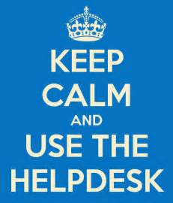
- Underwriting income calculations (SLA 4 hours) Underwriting scenarios (SLA 1 hour) Underwriting questions (SLA 1 hour)
- Because this is not a public site, you can attach loan level documents to the question without a fear of NPPI concerns.
- ALL QUESTIONS FOR LOANS IN PROCESS WILL STILL BE ESCALATED TO THE UWER ON THE FILE
- There is an FAQ database that is very user friendly with search functionality (currently building this knowledge base)
- Compliance and training (answered by those depts) are also available through the helpdesk and we will let you know as additional departments onboard (DU issues will generally be handled by training and may be sent to uwing by training as needed)
  - Helpdesk hours: M-F 8:00am – 5:30pm EST (hrs may be extended later)

https://hallmarkhomemortgage.cayzu.com
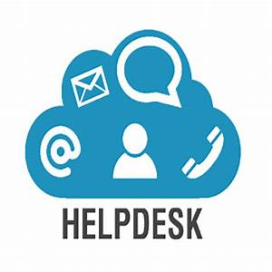
- DEAL STRUCTURES WILL STILL BE UTILIZED FOR ANYTHING LOAN LEVEL THAT HAS NOT BEEN REVIEWED BY AN UWER THAT IS NOT INCOME RELATED

